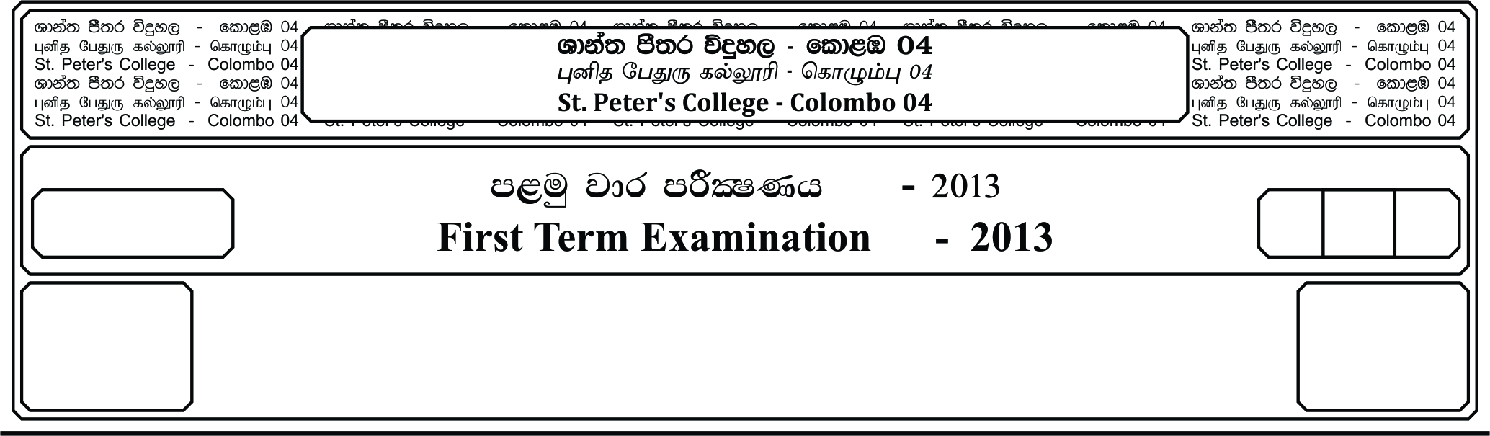

13 fY%aKsh

GRADE 13

E

meh

Hour

II

**f;jk jdr mÍCIKh - 2021**

**Third Term Examination - 2021**

wd¾Ól úoHdj - »»

**ECONOMICS – II**

**Instructions:**

↓ **Answer five questions only. Selecting minimum of two questions from sub-section A and two questions from sub-section B.**

**Sub-section A**

01. i. Distinguish between social capital and human capital.

ii. Contrast how a market economy and a command economy try to cope with the problem of scarcity.

iii. It is often said that there is consumer sovereignty in a market economy. Examine this argument.

iv. Explain law of increasing apportunity cost.

v. Explain the following events by using production possibility curve diagrams.

a. Drop in agricultural production due to a shortage of fertilizer.

b. Out migration of Sri Lankan professionals.

c. Less investments in the country due to covid 19 pandemic.

d. Increase in unemployment rate in the country.

***(04 Marks for a part)***

02. i. What are the factors that determine the market supply of agricultural goods?

ii. Distinguish between income effect and substitution effect.

iii. What are the reasons behind law of supply?

iv. “For an equilibrium in a free market, the minimum quantity supplied should be less than the minimum quantity demanded.” Explain this statement using a diagram.

v. Explain what is meant by orice supports system by using a diagram.

***(04 Marks for a part)***

03. i. Explain how the law of diminishing returns and the law of returns to scale affect a firm’s

cost of production. ***(04 Marks)***

ii. Discuss weather there is a relationship between the marginal cost curve of the firm and the supply curve of the industry to which it belongs. ***(04 Marks)***

iii. Whay do we make the following conclusions about a firm in perfect competition?

a. The firm is a price taker.

b. The average revenue and the marginal revenue of the firm and equal.

c. The firm can earn only normal profits in the long run. ***(12 Marks)***

04. i. What is meant by production boundry?

ii. Distinguish between Gig economy and Gray economy.

iii. National accounts fail to take into account the effects of production on the environment. Briefly comment on this statement.

iv. Outline gross domestic fixed capital formation by asset.

v. You are given the following national income accounting data of an economy. (Figures are in Rs. Millions.)

Compensation of employees 26,000

Gross operating surplus 7,000

Mixed income 6,000

Consumption of fixed capital 2,000

Other taxes less subsidies on products 1,000

Texes less subsidies on products 500

Net primary income from rest of the world 200

Compute the following :

a. GVA b. GDP c. GNI d. NNI

05. i. Explain how the condition of macroeconomic equailibrium change when a closed

economy moves into an open economy.

ii. Explain how the multiplier is calculated in a simple economy.

iii. Calculate the first four rounds of the multiplier effects for an increase of Rs. 200 billion in investment spending for a closed economy without a government sector where the MPC is 0.9.

iv. Suppose in a closed economy, planned saving is greater than planed investment. Under such situation explain how the economy achieves equilibrium level of national income.

v. The following macroeconomic data is given for a closed economy. (All figures are in Rs. million)

Consumption (C) = 100 + 0.75 Yd

Investment (I) = 150

Government purchases (G) = 100

Taxes (T) = 60

Household transfers (Tr) = 20

Determine the equilibrium level of national income for this economy.

***(04 Marks for a part)***

**Sub-section B**

06. i. “The demand for money varies with the interest rate.” Explain this statement using a diagram.

ii. “Central bank is the lender of the last resort.” Explain.

iii. “A rise in wages is always inflationary.” Comment on this statement.

iv. Explain how the central bank can interwene to restrict the growth of or to reduce the money supply.

v. Assume that for a hypothetical economy narrow money supply (M1) is Rs. 4200 billion, total bank deposits are Rs. 4000 billion, currency held by the bank is Rs. 100 billion, the statutory reserve ration is 10% and the banks do not hold excess reserves.

a. What is the value of money multiplier for this economy?

b. If the central bank introduces standing lending facility for Rs. 50 billion for the commercial banks, what is the greatest amount by which total money supply could change?

***(04 Marks for a part)***

07. i. What important features do you observe in the structure of the government revenue in Sri Lanka in recent years?

ii. “The size of the deficit in the government budget does not matter. What is important is that the deficit be financed by non-inflationary sources” Do you agree with this view? Give reasons.

iii. Distinguish between public goods and merit goods.

iv. Explain how a government budget can promote economic growth in a country.

v. Are there other costs and benefits in production and consumption? Give an example of such cost and benefits from production and consumption.

***(04 Marks for a part)***

08. i. Distinguish between comparative advantage and competitive advantage. ***(04 Marks)***

ii. Distinguish between nominal exchange rate and effective exchange rate. ***(04 Marks)***

iii. Suppose that there are 10 million workers in Canada and that each of these workers can produce either 2 cars or 30 bushels of wheat in a year.

a. What is the opportunity cost of producing a cars and a bushels of wheat in Canada.

b. Draw Canada’s production possibilities frontier. If Canada chooses to consume 10 million cars, how much wheat can it consume without trade? Lable this point on the production possibilities frontier.

c. New suppose that the United States offers to buy 10 million cars from Canada in exchange for 20 bushels of wheat per car. If Canada continuous to consume 10 million cars, how much wheat does this deal allow Canada to consume? Lable this point on your diagram. ***(12 Marks)***

09. i. What changes do you see in the overall unemployment rate of Sri Lanka in the last 10 years?

ii. What is meant by macroeconomic imbalance?

iii. What roles can government play in promoting economic growth?

iv. What are the most inhibit growth in developing countries including Sri Lanka?

v. “Growth rate in the agricultural sector of Sri Lanka has been very low due to deep-rooted structural weaknesses.” Identify the deep-rooted structural weaknesses hindering the growth of agricultural output.

***(04 Marks for a part)***

10. i. Internationa economic organization often advise developing countries to carry out structural adjustments in their economies.

a. What do structural adjustment include?

b. What problems are encounted in carrying out these changes. ***(08 Marks)***

ii. Assume that you are asked to prepare a report on the performance of the central trade and finance sector of the Sri Lankan economy in a given year.What are the key indicators that you would include in such a report. ***(04 Marks)***

iii. Write a short note on micro-finance as an instrument that could be used for poverty reduction. ***(04 Marks)***

iv. Breifly describe the role of international monetary fund. (IMF) ***(04 Marks)***